Gparted Exercise 1

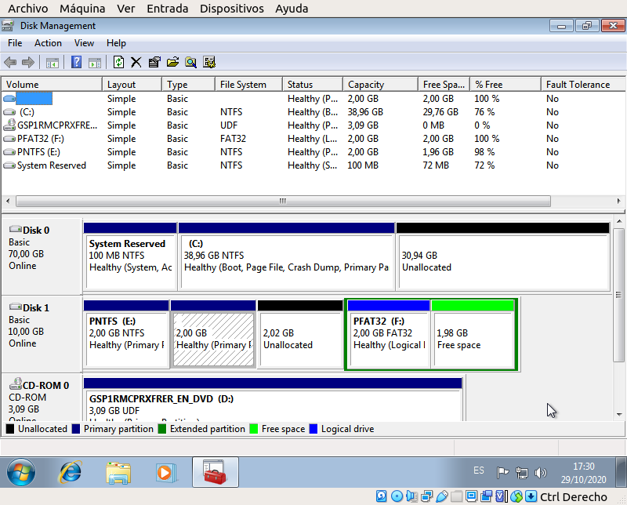
The file system is not shown on the second partition because it is a EXT4 partition.
In order to store 2 GB we can create a new logical partition that has a 2 GB capacity.

Gparted exercise 2.

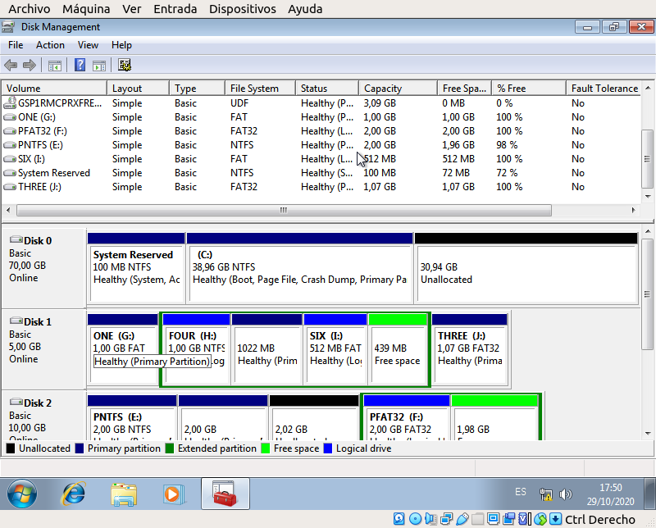
Gparted names the new hard drive disk “dev/sda3” because it is the third hard drive in the computer.
The partitions I created (in order) were:
-1 GB primary FAT16 Partition named ONE.
-3 GB extended partition named TWO.
Inside the extended partition I created were:
- 1GB NTFS logical partition named FOUR.
-1 GB EXT4 primary partition named FIVE.
-512 MB FAT32 logical partition named SIX.
In the remaining space after the extended partition:
-1.07 GB FAT32 primary partition named THREE.

